Test Driven Development of VM instance manager SPA

**Abstract – This paper reviews the latest industrial software engineering techniques, architecture, tools and cycles present in developing modern single page web applications. As well as current VM management solutions are discussed and evaluated from functionality, portability, accessibility, ease of set up, and cost perspectives. Later a conclusion is drawn to produce a context for a possible development project.**

**Introduction**

Development of single page web applications has become a cutting edge approach in producing cross platform and responsive, desktop like web applications [1]. In the course of last 20 years, SPA’s have evolved from being plug-in supported technologies such as Flash and Java applets to natively in browser supported ES6 JavaScript applications.

**SPA development architecture and technologies**

*Front-end, backend Arch

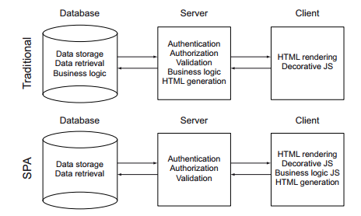

*Frontend tools, backend Tools

* rest api, Graph QL

**Full SPA development cycle**

*Architecture, functional specification, Test Specification, Test, Dev, Deploy

**Evaluation of VM access and management tools**

**Conclusion**

Lack file exploration, ease of set up, file editing, ease of accessibility. Developing a SPA application could eliminate those problems and prove a great industrial usage case.